# Lab 1: Sign up Page

In the first lab, we try to create the Sign up section of the following screenshot.

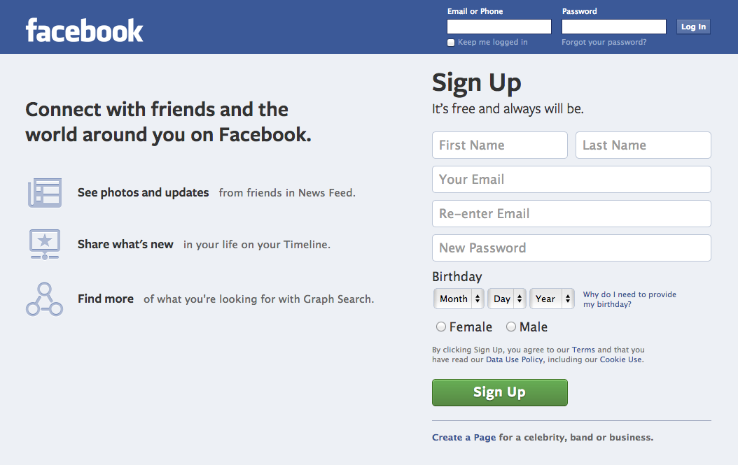

## HTML

Fire up your favorite editor (Sublime Text 2) and type the following HTML code

<html>

<head>

<title>Sign up</title>

</head>

<body>

<h1>Sign Up</h1>

<h2>It's free and always will be.</h2>

<form name="register" method="post" action="/register">

<div>

<input type="text" name="first_name" placeholder="First Name" />

<input type="text" name="last_name" placeholder="Last Name" />

</div>

<div>

<input type="text" name="email" placeholder="Your Email" class="email" />

</div>

<div>

<input type="text" name="email_confirmation" placeholder="Re-enter Email" class="email" />

</div>

<div>

<input type="password" name="password" placeholder="New Password" class="password">

</div>

<div class="birthday">

<div>Birthday</div>

<select>

<option value="0">Month</option>

<option value="1">Jan</option>

<option value="2">Feb</option>

<option value="3">Mar</option>

<option value="4">Apr</option>

<option value="5">May</option>

<option value="6">Jun</option>

<option value="7">Jul</option>

<option value="8">Aug</option>

<option value="9">Sep</option>

<option value="10">Oct</option>

<option value="11">Nov</option>

<option value="12">Dec</option>

</select>

<select>

<option>Day</option>

</select>

<select>

<option>Year</option>

</select>

</div>

<div class="sex">

<input type="radio" name="sex" value="1" id="female">

<label for="female">Female</label>

<input type="radio" name="sex" value="1" id="male">

<label for="male">Male</label>

</div>

<p>By clicking Sign Up, you agree to our <a href="/legal/terms" target="_blank">Terms</a> and that you have read our <a href="/about/privacy" target="_blank">Data Use Policy</a>, including our <a href="/help/cookies" target="_blank">Cookie Use</a>.</p>

<button type="submit" name="websubmit">Sign Up</button>

</form>

</body>

</html>

## CSS

<style type="text/css">

body {

background: #edf0f5;

}

h1 {

color: #333;

font-size: 36px;

}

h2 {

color: #333;

font-size: 19px;

}

input {

font-size: 18px;

padding: 8px 10px;

}

input.email, input.password {

width: 433px;

}

.birthday {

font-size: 18px;

color: #333;

}

.birthday div {

margin: 10px 0;

}

select {

font-size: 13px;

min-width: 65px;

height: 30px;

padding: 5px;

border: 1px solid #bdc7d8;

}

.sex {

margin: 10px 0;

font-size: 18px;

color: #333;

}

button {

background: -webkit-linear-gradient(top, #79bc64, #578843);

-webkit-box-shadow: inset 0 1px 1px #a4e388;

min-width: 194px;

padding: 7px 20px;

border: 1px solid;

border-color: #3b6e22 #3b6e22 #2c5115;

border-radius: 5px;

color: #fff;

font-size: 19px;

text-shadow: 0 1px 2px rgba(0,0,0,0.5);

cursor: pointer;

}

a {

text-decoration: none;

}

a:hover {

text-decoration: underline;

}

</style>